Project Proposal for Toyswap

1. What tech stack will you use for your final project?

**I will use React and Node for this project.**

1. Is the front-end UI or the back-end going to be the focus of your project? Or are you going to make an evenly focused full-stack application?

**I will focus on the backend and if I have enough time, I’ll work more on frontend as well.**

1. Will this be a website? A mobile app? Something else?

**It will be a website.**

1. What goal will your project be designed to achieve?

**That would be the app where parents can exchange toys for their kids. It’ll be like a Facebook marketplace but for toys, they can exchange it for free, get rid of the ones their kids don’t play with anymore, and get new ones. There will be a page where parents can sell toys if they want. There will be a condition where you can’t get more toys if you haven't shared at least 3 more toys than you got. The parents will be able to chat and leave reviews about other parents.**

1. What kind of users will visit your app? In other words, what is the demographic of your users?

**The primary users will be parents of little kids who grew out of the toys they have.**

1. What data do you plan on using? How are you planning on collecting your data? You may have not picked your actual API yet, which is fine, just outline what kind of data you would like it to contain. You are welcome to create your own API and populate it with data. If you are using a Python/Flask stack are required to create your own API.

**I didn’t find an API that would be useful for my app, so I’ll probably create my own.**

1. In brief, outline your approach to creating your project (knowing that you may not know everything in advance and that these details might change later). Answer questions like the ones below, but feel free to add more information:
   1. What does your database schema look like?

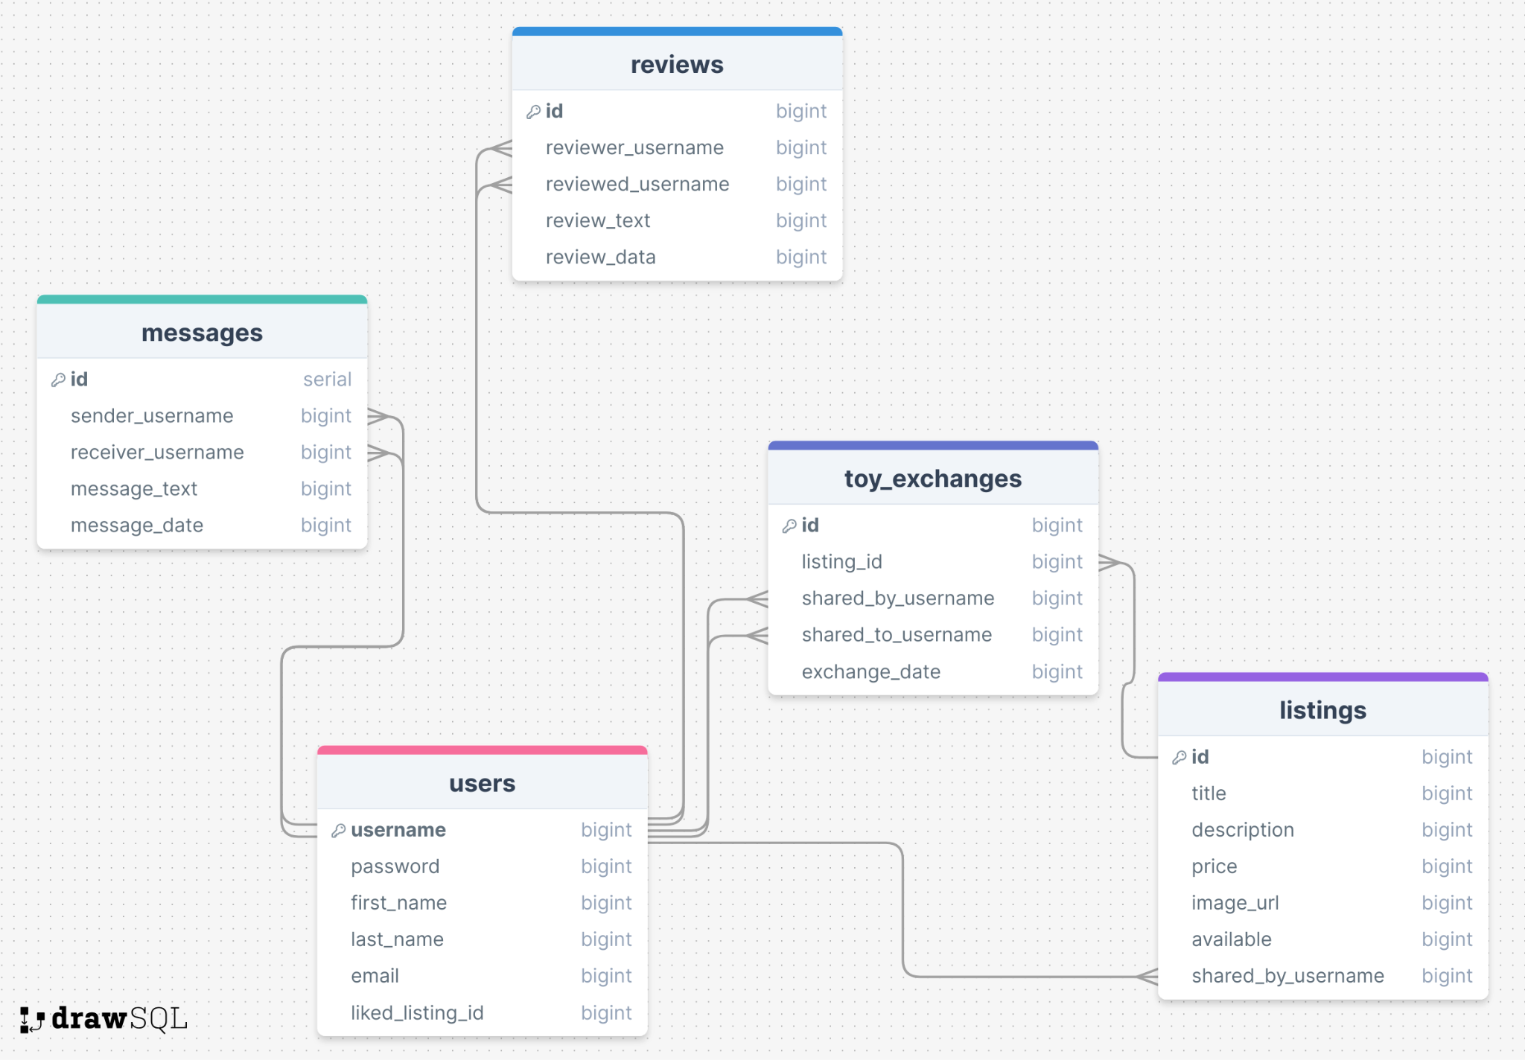

* 1. What kinds of issues might you run into with your API? This is especially important if you are creating your own API, web scraping produces notoriously messy data.
  2. Is there any sensitive information you need to secure?

**Yes. Passwords, chats.**

* 1. What functionality will your app include?

**It will have messaging between two users, users can leave reviews.**

* 1. What will the user flow look like?

**User signs up, logs in, on the home page he can see a list of available toys which he can add to “favorite” and get. He can list toys he wants to sell or give away. He can chat with a seller. After he gets/buys a toy, he can leave a reviews about the seller and the seller can leave reviews about him.**

* 1. What features make your site more than a CRUD app? What are your stretch goals?

**It’ll have reviews, chat, authentication and authorization, search and filter. Stretch goals are creating a mobile app, connecting the app with the Facebook market so you can post a listing on Facebook as well.**

**https://github.com/MaryiaKunkel/toyswap**